Escambia-Santa Rosa Bar Association
Escambia County Courthouse Access ID Badge Application
April 1, 2018 to March 31, 2020

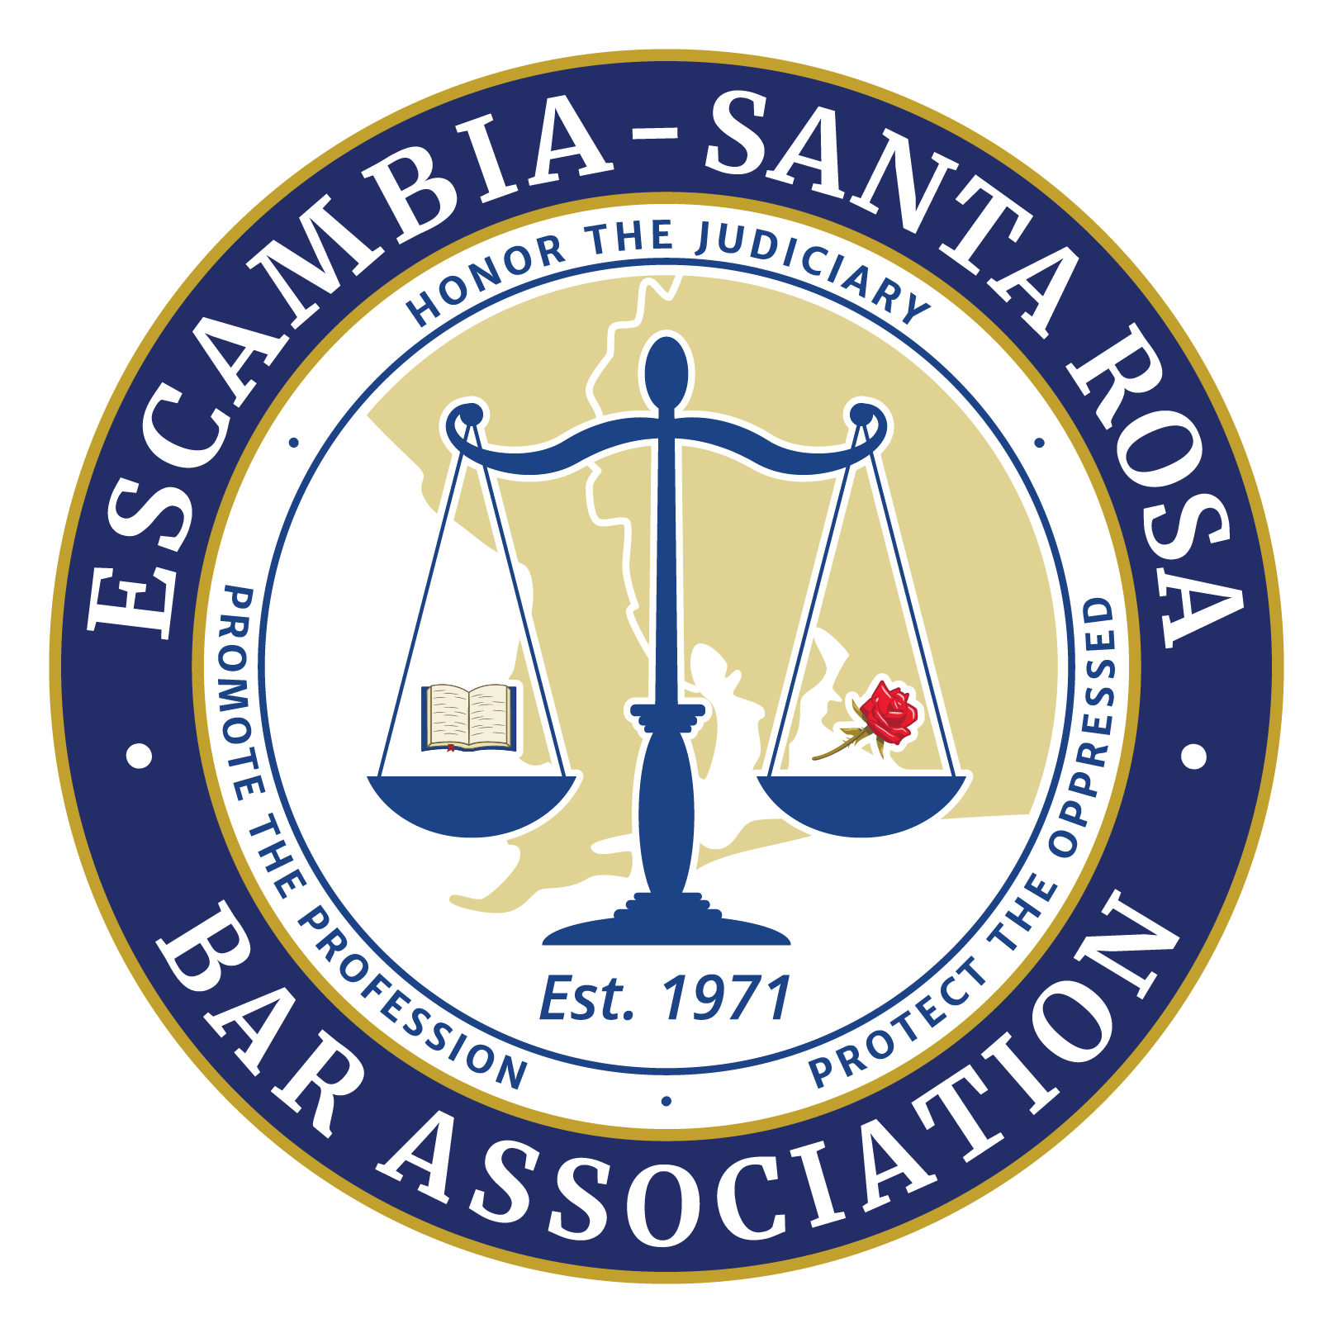

Please complete and sign this form and deliver or mail it to the Escambia-Santa Rosa Bar Association with your check or credit card payment. Badge expiration date will be March 31, 2026

First Name ______________________ Middle Initial __________ Last Name ______________________

Mailing Address _______________________________________________________________________

City ___________________________ State _____________ Zip _________________________________

Email Address _________________________________ Work Phone _____________________________

Florida Bar Number ____________________________________________________________________

I certify that as a condition of issuance of the Escambia County Courthouse Access Badge (Badge) by the Escambia-Santa Rosa Bar Association (ESRBA), I will not allow anyone else to use said Badge for access to the Escambia County Courthouse. If said Badge is lost or stolen, I will immediately report it to the ESRBA.

I acknowledge and agree that said Badge is not an official State of Florida identification card and affords no rights or privileges of an official State of Florida identification card.

I acknowledge and agree that the validity of the Badge is contingent on my status as a member in good standing with The Florida Bar. If, for whatever reason, I am no longer a member in good standing with The Florida Bar, I will voluntarily surrender the Badge to the ESRBA.

I agree to present the Badge to the security personnel at the M.C. Blanchard Judicial Building and T. Bruno Juvenile Justice Center checkpoints in order to be excluded from removing my belt and wrist watch only. I also acknowledge I still must be screened and present my belongings to be screened.

I acknowledge and agree that access to the Escambia County Courthouses is subject to the policies and procedures that the First Judicial Circuit Court Administration may from time to time adopt at its discretion. I further acknowledge and agree that the Badge may be revoked or canceled or its benefits limited by the First Judicial Circuit Court Administration or the ESRBA. I release the First Judicial Circuit Administration and the ESRBA from any actions to said revocation, cancellation or limitation. I also indemnify the ESRBA of all liability for any and all misuse of this badge.

Signature ________________________________________ Date ________________________________

Fee: $50.00
Make checks payable to: Escambia-Santa Rosa Bar Association
Return application and payment to: 260 S. Tarragona St. Suite 160 Pensacola, FL 32502

Credit Card Info:
Full Name on the Credit Card_________________________________________________
Credit Card number ________________________________________________________
Experation Date ___________________________________ Security Code ____________

- Please Email request to Stephen@esrba.com. Thank You

